






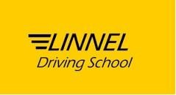
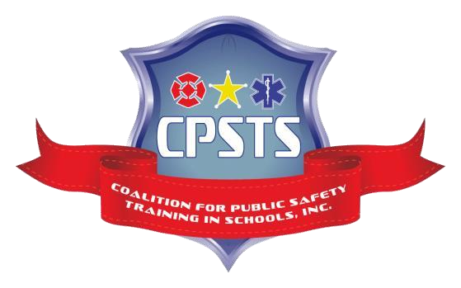

“Prince George’s County Public Schools is not sponsoring, endorsing, or recommending the activities announced in this flyer/material.”

Scholarship Program
for
Linnel Driving School
&
Coalition for Public
Safety Training in
Schools, Inc. (CPSTS)

“Providing pathways for youth into Public

Safety
careers
in Prince George’s County”

School Years
2020 – 2021
CTE.NEED.MERIT

Scholarship Application Requirements
FOR AN APPLICATION TO BE CONSIDERED, YOU MUST:
- Be a resident, living in Prince George’s County Maryland.
- Be a student of a PGCPS High School Junior or Senior class.
- Have a commitment from parent(s) to ensure the student attends all sessions.
- Must meet one of the eligibility requirements of
  - Enrolled in a CTE Program, or
  - Eligible for Free/Reduced Lunch program with a minimum of a 2.0 GPA, or
  - A Grade Point Average (GPA) of 3.0 or above.
- Complete all questions and include all signatures.
- Answer the 250-word essay question.
- Submit the completed application by December 21, 2020.
Email Completed Application to: info@cpsts.org

For questions or further information, please contact:

Mr. William Taylor at 240-508-4203 or info@cpsts.org
Mr. Linwood Nelson at (C) 301-996-2459 (Office) 301-341-1700

DEADLINE: Applications must be received by December 21, 2020.

SCHOLARSHIP APPLICATION
(Please PRINT and answer all questions)
Mark Application Type ____ CTE Program Enrollee ____ Financial Need ____Merit Based
____ Lay-DC.org
School Name __________________________________ Grade ____________
Full Name___________________________________

D.O.B
Age
Home Address

Town, Zip ___ _ ,__________ ______________________ Zip___________________
Gender ____________ Race ______________
Applicant Email
Applicant Cell Phone
Home Telephone Number___________________________________________________________
Parent Name _______________________________________________________________________
Parent Phone # and Email (home)_____________________________________________________________________________
Parent Phone # and Email (work) ___________________________________________________
Parent Signature ___________________________________________________________________
PLEASE NOTE:
- This application applies to PGCPS Junior and Senior High School Students.
- Return completed application by December 21, 2020

ESSAY QUESTION: (Mandatory Response Required) MUST BE TYPED – ATTACH AS A SEPARATE PAGE – SEPARATE PAGE MUST include your full name and birth month and year.
250 word minimum, answer the following question. “How will a driver’s license help you to gain sustainable employment in your chosen course of study?”
Extra-curricular activity: (Mandatory Response Required) MUST BE TYPED – ATTACH AS A SEPARATE PAGE – SEPARATE PAGE MUST include your full name and birth month and year. Use N/A if Not Applicable
Community Service: (Mandatory Response Required) MUST BE TYPED – ATTACH AS A SEPARATE PAGE – SEPARATE PAGE MUST include your full name and birth month and year. Use N/A if Not Applicable

Standard Operating Procedures and Policies
- All students are expected to arrive on time, prepared to take notes and participate in all classroom and behind the wheel activities.

- There will be respect between all students and all Linnel Driving School instructors and staff, everyone will be treated with kindness, respect and professionalism.

- All classroom and cars are to be treated with appreciation and not to be damaged or vandalized. If so, it will be the responsibility of the parent to reimburse the driving school for the damage or repairs.

- No profanity, horse playing, disrespect toward the instructor or disruptive classroom activities including, but not limited to: spitting, cussing, yelling, inappropriate conversation, classroom cell phone use, abusive entering and exiting of the classroom will NOT be tolerated and can be grounds for immediate expulsion from the scholarship program.

Step One: | Parent/instructor/student telephone conference.
Step Two: | If no improvement, mandatory parent classroom attendance to encourage positive student behavior and minimize disruptive behavior.
Step Three: | If no improvement is observed, the student may be expelled from the scholarship program.
- Any negative issues will be addressed by the following process:

Acknowledgement: I acknowledged that I have read and agree to abide by the Standard Operating Procedures and Policies listed on page 5.

________________________________________________________________________
Parent/Guardian Name (Print)

________________________________________________________________________
Parent/Guardian Signature

Date _________________________________________________

- Maryland Motor Vehicle Administration (MVA) requires each student who drives the car to have a valid learner’s permit. Also, all students must hold a valid learner’s permit for nine months before taking the MVA Road Test to get his or her license. Students are required to obtain 60 hours of driving practice with a parent or mentor during the holding period.
- Maryland Motor Vehicle Administration requires the parent’s participation and involvement in training students in the car with practice.
- Students are required to have at least 20 hours of Behind-the-Wheel practice with the parent or mentor before the 1st Behind-the-Wheel evaluation.
- Students are required to have at least 40 hours of Behind-the-Wheel practice with the parent or mentor before the 2nd Behind-the-Wheel evaluation.
- Students are required to have at least 60 hours of Behind-the-Wheel practice with the parent or guardian before the 3rd Behind-the-Wheel evaluation.
_______________________________________________________________________
Student SIGNATURE DATE
_______________________________________________________________________
Parent SIGNATURE DATE

Linnel Driving School DATE

